2299 DEFINITIONS

2299.1 When used in this chapter, the following terms and phrases shall have the meanings ascribed:

Accident - an unexpected, undesirable event, caused by the use or presence of a pesticide, that adversely affects man or the environment. (25 DCR 3044 incorporating 25 DCR 2118)

Active ingredient:

(a) In the case of a pesticide other than a plant regulator, defoliant, or desiccant, an ingredient that will prevent, destroy, repel, or mitigate any pest;

(b) In the case of a plant regulator, an ingredient that, through physiological action, will accelerate or retard the rate of growth or maturation, or otherwise alter the behavior of ornamental or crop plants or the product of the plants;

(c) In the case of a defoliant, an ingredient that will cause the leaves or foliage to drop from a plant; and

(d) In the case of a desiccant, an ingredient that will artificially accelerate the drying of plant tissue.

Administrator - the Administrator of the United States Environmental Protection Agency.

Adulteration - a pesticide having a strength or purity that falls below the professed standard or quality as expressed in its labeling under which it is sold; or the total or partial substitution of any substance for the pesticide; or the total or partial abstraction of any valuable constituent, of the pesticide.

Agricultural commodity - any plant or part of a plant, or an animal or animal product, produced by a person (including farmers, ranchers, vineyardists, plant propagators, Christmas tree growers, aquaculturists, floriculturists, orchardists, foresters, or other comparable persons) primarily for sale, consumption, propagation, or other use by man or animals. (25 DCR 3044 incorporating 25 DCR 2118)

Animal - all vertebrate and invertebrate species, including, but not limited to, man and other mammals, birds, fish, and shellfish.

Biopesticide - a chemical derived from plants, fungi, bacteria, or other non-man-made synthesis that is effective in controlling target pests or certain microorganisms including bacteria, fungi, viruses, and protozoa that are effective in controlling target pests. These agents usually do not have toxic effects on animals and people and do not leave toxic or persistent chemical residues in the environment.

Certification - the recognition by a certifying agency that a person is competent and is authorized to use or supervise the use of restricted use pesticides. (30 DCR 2204)

Certified applicator - any individual who is certified by the Mayor as being competent to use or supervise the use of any restricted use pesticide or class of restricted use pesticides covered by his or her certification.

Commercial applicator - an individual, whether or not he or she is a private applicator with respect to some uses, who uses or supervises the use of any pesticide that is classified for restricted use for any purpose or on any property other than as provided by the definition of "private applicator."

Competent - properly qualified to perform functions associated with pesticide application, the degree of capability required being directly related to the nature of the activity and the associated responsibility. (25 DCR 3044 incorporating 25 DCR 2118)

Defoliant - any substance or mixture of substances intended for causing the leaves or foliage to drop from a plant, with or without causing abscission.

Desiccant - any substance or mixture of substances intended for artificially accelerating the drying of plant tissue.

Device - any instrument or contrivance (other than a firearm) that is intended for trapping, destroying, repelling, or mitigating any pest of any other form of plant or animal life (other than man and other than bacteria, virus, or other microorganism on or in living man or other living animals); but not including equipment used for the application of pesticides when sold separately from the pesticides.

Director - the Director of the Department of Environmental Services or the Director's designated agent.

Distribute - to offer for sale, hold for sale, sell, barter, or trade a commodity.

District - the District of Columbia.

Environment - includes water, air, land, and all plants and man and other animals living in or on the water, air, and land; and the interrelationships that exist among these things. (25 DCR 3044 incorporating 25 DCR 2118)

Equipment - any type of ground, water, or aerial equipment or contrivance using motorized, mechanical, or pressurized power, and used to apply any pesticide on land and anything that may be growing, habitating, or stored on or in the land. This term shall not include any pressurized hand-sized household apparatus used to apply a pesticide.

FIFRA - the Federal Insecticide, Fungicide, and Rodenticide Act (7 USC 135 et seq.), as amended.

Fumigation - the act of releasing or dispensing a toxic chemical agent in such a way that it reaches the organism wholly or primarily in the gaseous state. (25 DCR 3044 incorporating 25 DCR 2118)

Fungus - any non-chlorophyll-bearing thallophyte (any non-chlorophyll-bearing plant of a lower order than mosses and liverworts); for example: rust, smut, mildew, mold, yeast, and bacteria, except those on or in living man or other animals and those on or in processed food, beverages, or pharmaceuticals.

Hazard - a probability that a given pesticide will have an adverse effect on man or the environment in a given situation, the relative likelihood of danger or ill effect being dependent on a number of interrelated factors present at any given time. (25 DCR 3044 In carp orating 25 DCR 2118)

Inert ingredient - an ingredient that is not active. (25 DCR 3044 incorporating 25 DCR 2118)

Ingredient statement - a statement that contains:

(a) The name and percentage of each active ingredient, and the total percentage of all inert ingredients in the pesticide; and

(b) If the pesticide contains arsenic in any form, a statement of the percentages of total and water soluble arsenic, calculated as elemental arsenic. (25 DCR 3044 incorporating 25 DCR 2118)

Insect - any of the numerous small invertebrate animals generally having a body more or less obviously segmented, for the most part belonging to the class insecta, comprising six (6) legged, usually winged forms (for example, beetles, bugs, bees, and flies). For purposes of Chapters 22 through 25 of this subtitle, the term "insect" also applies to allied classes of arthropods whose members are wingless and usually have more than six (6) legs (for example, spiders, mites, ticks, centipedes, and wood lice).

Label - the written, printed, or graphic matter on, or attached to, the pesticide or device or any of its container or wrappers.

Labeling - all labels and all other written, printed, or graphic matter that does the following:

(a) Accompanies the pesticide or device at any time; or

(b) Accompanies or refers to the pesticide or device, except when accurate non-misleading references are made to current official publications of federal or state institutions or agencies authorized by law to conduct research in the field of pesticides.

Land - all land and water areas, including air space, and all plants, animals, structures, buildings, contrivances, and machinery appurtenant to or situated on the land and water areas, fixed or mobile, including any used for transportation.

Licensed certified applicator - an applicator who has completed the requirements for certification and holds a valid District license. (25 DCR 3044 incorporating 25 DCR 2118)

Mayor - the Mayor of the District of Columbia or the Mayor's designated agent.

Nematode - invertebrate animals of the phylum nemathelminthes and class nematoda; that is, unsegmented round worms with elongated, fusiform, or sac-like bodies covered with cuticle, and inhabiting soil, water, plants, or plant parts. A nematode also may be called nemas or eelworms.

Ornamental - trees, shrubs, and other plantings in and around habitations, generally, but not necessarily, located in urban and suburban areas, including residences, parks, streets, retail outlets, and industrial and institutional buildings. (25 DCR 3044 incorporating 25 DCR 2118)

Person - any individual, partnership, association, corporation, company, joint stock association, or any organized group of people whether incorporated or not. This term includes any trustee, receiver, or assignee.

Pest - any insect, rodent, nematode, fungus, weed, or any other form of terrestrial or aquatic plant or animal life or virus, bacteria, or other microorganism (except viruses, bacteria, or other microorganism on or in living persons or other living animals) that commonly is considered to be detrimental to a person or mankind's interests, or which the Mayor may declare to be detrimental.

Pesticide - any substance or mixture of substances intended to prevent, destroy, repel, or mitigate any pest; and any substance or mixture of substances intended for use as a plant regulator, defoliant, or desiccant.

Pesticide applicator - an individual who is a commercial applicator, private applicator, public applicator, or registered employee.

Pesticide dealer - any person who distributes to the ultimate user restricted use pesticides or any pesticide whose use or distribution are further restricted by the Mayor.

Pesticide operator - :

(a) Any person who owns or manages a pesticide application business in which pesticides are applied upon the lands of another for hire or compensation; or

(b) Except as otherwise provided under the definition of "private applicator," the owner or manager of any commercial firm, business, corporation, or private institution, who directly or through his or her employees uses restricted use pesticides on property owned, managed, or leased by the commercial firm, business, corporation, or private institution; or

(c) Any District or other governmental agency whose officials or employees apply pesticides as part of their normal duties.

Place of business - a location that is staffed by at least one (1) person who independently, without supervision, applies pesticides or who supervises others in the use of pesticides. (25DCR 3044 incorporating 25 DCR 2118)

Plant incorporated protectant - pesticidal substances that are intended to be produced and used in a living plant or in the produce thereof, and the genetic material necessary for production of such a pesticidal substance. Plant incorporated protectant also includes any inert ingredient contained in the plant, or produce thereof.

Plant regulator - any substance or mixture of substances intended, through physiological action, for accelerating or retarding the rate of growth or rate of maturation of plants; or for otherwise altering the behavior of plants or the produce of the plants. This term shall not include substances to the extent that they are intended as plant nutrients, trace elements, nutritional chemicals, plant inoculants, and soil amendments. Also, it shall not be required to include any of those nutrient mixtures or soil amendments as are commonly known as vitamin-hormone horticultural products, intended for improvement, maintenance, survival, health, and propagation of plants, and that are not for pest destruction, and that are nontoxic, nonpoisonous in the undiluted packaged concentration.

Private applicator - any individual who uses any restricted use pesticide for purposes of producing any agricultural commodity on property owned or rented by the individual or his or her employer; or, if applied without compensation other than trading of personal services between producers of agricultural commodities, on the property of another person.

Protective equipment - clothing or any other materials or devices that shield against unintended exposure to pesticides. (25 DCR 3044 incorporating 25 DCR 2118)

Public applicator - a commercial applicator who is an employee of the District or of a governmental agency who is authorized to use or supervise the use of pesticides.

Registered employee - an individual who is registered with the Mayor, pursuant to § 2204 of this Chapter, and who works under the direct supervision of a licensed commercial or public applicator.

Registrant - any person who registers any pesticide pursuant to. the provisions of the Act. (25 DCR 3044 incorporating 25 DCR 2118)

Registration - includes reregistration. (25 DCR 3044 incorporating 25 DCR 2118)

Restricted use pesticides - any pesticides (or pesticide use) classified by the Administrator for restricted use; or any pesticide which, when used as directed or in accordance with commonly recognized practice, the Mayor determines, subsequent to a hearing, that additional restrictions for that use are necessary in order to prevent a hazard to the applicator or other persons, or to prevent unreasonable adverse effects upon the environment.

Space treatment - the dispersal of insecticides into the air by foggers, misters, aerosol devices, ultra low volume (ULV) equipment, or vapor dispensers for the control of flying insects and exposed crawling insects. (25 DCR 3044 incorporating 25 DCR 2118)

Under the direct supervision of - unless otherwise prescribed by its labeling or other restrictions imposed by the Mayor, a pesticide shall be considered to be applied under the direct supervision of a certified applicator if it is applied by a competent registered employee acting under the instruction and control of a certified applicator who is available if and when needed, even though the certified applicator may not be physically present at the time and place the pesticide is applied.

Weed - any plant that grows where it is not wanted.

SOURCE: Section 2 of the Pesticide Operations Act of 1977, D.C. Law 2-70, 25 DCR 6867, 6882 (February 19, 1978); as amended by Final Rulemaking published at 25 DCR 3044 (October 6, 1978), incorporating Proposed Rulemaking published at 25 DCR 2118 (August 25, 1978); Final Rulemaking published at 30 DCR 2204 (May 13, 1983); as amended by Final Rulemaking published at 55 DCR 9839 (September 19, 2008).

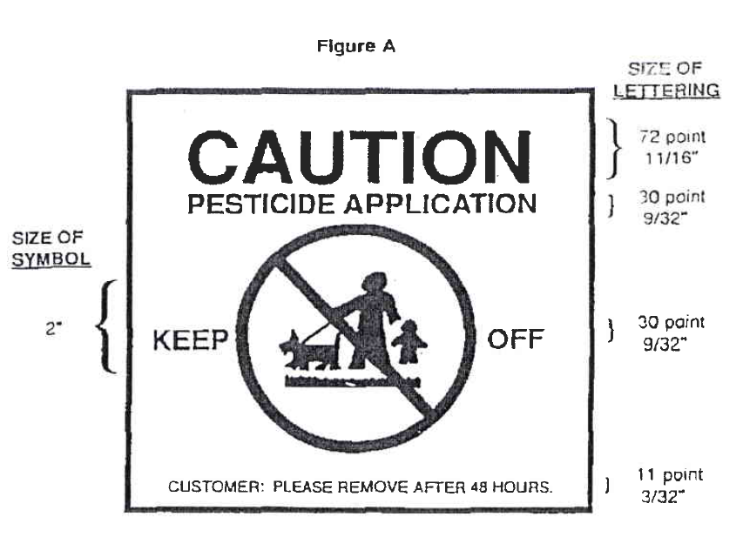
SOURCE: As amended by Final Rulemaking published at 55 DCR 9839 (September 19, 2008).

